

Streamlit Project Dashboard
Data Analytics and Artificial Intelligence Tools 2 (Gpo 101)

Team: Le Frites

Names and IDs:

Arath Mendivil Mora - A01660670

Lázaro Rodríguez Bedolla - A00838171

Marius Ismael Calves - A01831309

Humberto Gonzalez Escamilla - A00837328

Andrés Montemayor Tatum - A01383664

November 17, 2025
Dataset Snapshot and Schema (Expandable Section)
Location: Top of Page 1
Purpose: Provide transparency into the raw data used to power the insights and predictions.

What it shows
- First 15 rows of the dataset
- Variable data types (int, float, object, datetime, etc.)
- Summary information:
  - Total date range available.
  - Number of Trade Partners.
  - Number of SKUs.

Why it matters
This section helps users:
- Validate that the uploaded dataset is the correct one.
- Understand what variables exist and how they are interpreted.
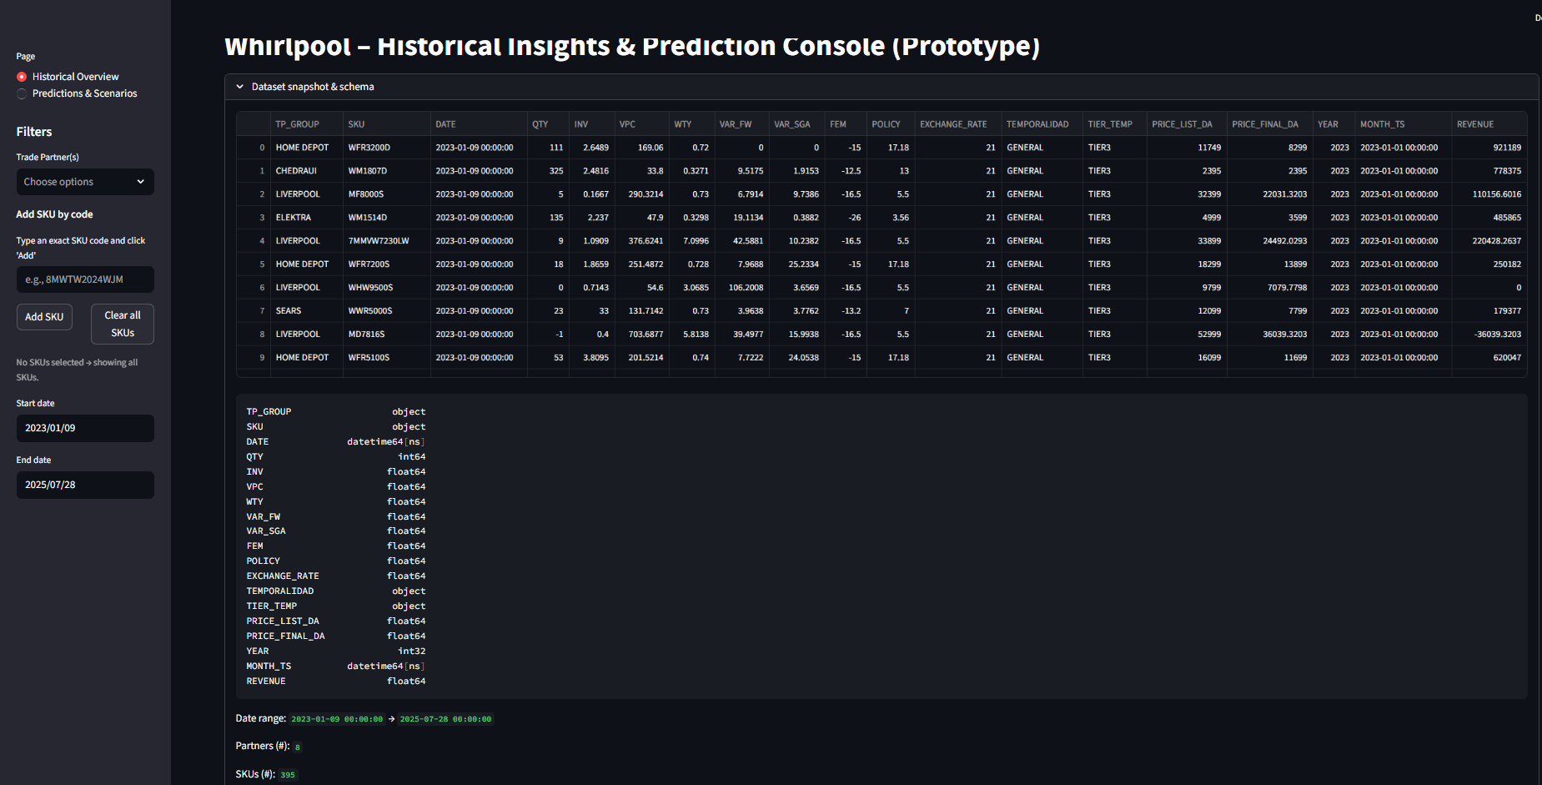
- Identify the temporal coverage.

Sidebar Navigation and Filters
Location: Left panel
Purpose: Allow the user to switch between Page 1 (Historical Overview) and Page 2 (Predictions & Scenarios); the filters affect everything on Page 1, including KPIs and charts. They do not affect Page 2.
Pages:
- Historical Overview: Visualization and exploratory analysis of past performance
- Predictions & Scenarios: ML-driven forecasts for hypothetical scenarios
Filter: Trade Partner Selector
- Users can select one or multiple Trade Partners.
- Only data belonging to those partners remains visible.

Filter: SKU Input System
Instead of selecting from a long list, the user manually enters SKU codes.
Workflow:
- Type SKU code -> press Add SKU
- SKU is validated:
  - If exists, added to selection
  - If not, warning appears
- The selected SKUs appear below and can be removed manually
- If no SKUs selected -> dashboard shows data for all SKUs

Why this design
- Manual input prevents long dropdowns with hundreds of SKUs
- Reduces noise in KPIs and charts
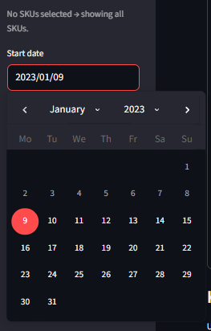
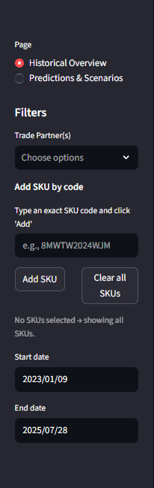
Filter: Date Range Selector
Shows two calendars:
- Start Date
- End Date

KPIs (Page 1)
Summarizes performance after applying user filters.

Displayed Metrics
- Total Units Sold (QTY)
- Average Final Price
- Average Inventory

Interpretation
These KPIs allow the user to quickly:
- Identify volume drivers
- Compare pricing behavior across partners or SKUs
- Understand overall filtered performance

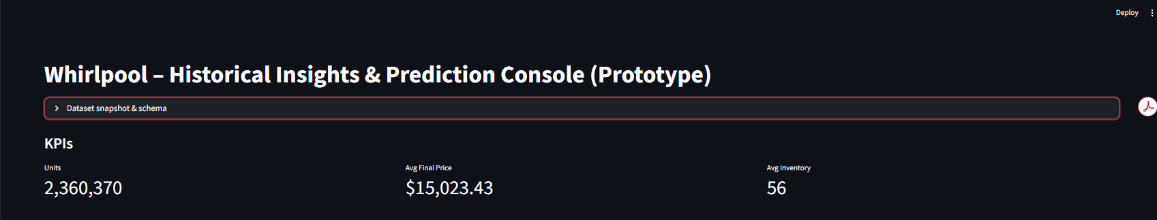
Note: These KPIs do not react to chart-only settings (granularity, top-N SKUs, week windows).

Overview Section (Charts on Page 1)
Visual insights into the historical behavior of the selected TP(s) and SKU(s).

Chart Controls (affect only the charts):
Granularity
- Month
- Quarter
- Week
Usage:
- Month and Quarter give a smoothed, higher-level view
- Week shows the closest resemblance to the day-to-day sales cycle
Top-N SKUs
- Helps limit noise
- Selects top SKUs based on revenue proxy
If no SKU is typed in sidebar -> dashboard automatically shows Top 5 SKUs.
12-Week Window (when Week granularity selected)
- User can select a date window of up to 12 weeks
- Used for short-term weekly analysis
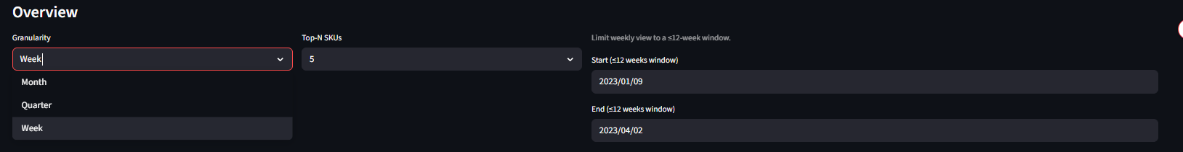
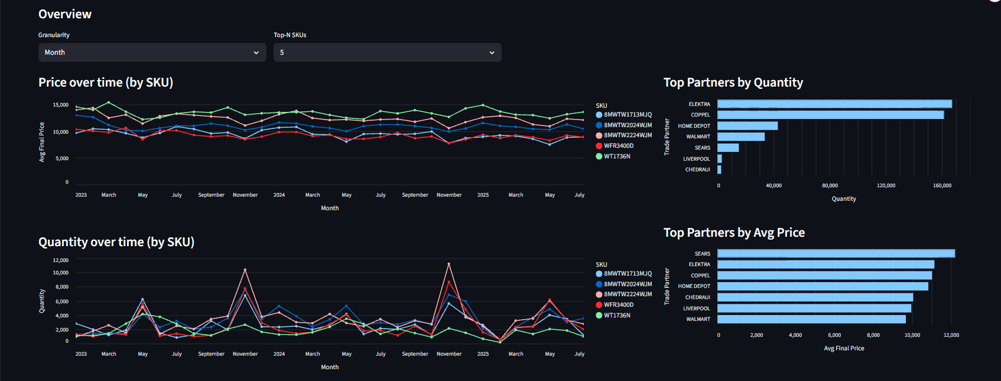
- The dashboard protects against longer selections automatically

Page 2 – Predictions & Scenario Builder
This page uses the XGBoost models trained in Colab to forecast:
- Final Price (weekly)
- Quantity Sold (weekly)

What drives the predictions
Models use only features that demonstrated predictive power:
- Seasonal patterns (sin/cos of week-of-year)
- TP and SKU encoded IDs
- Discount percentage
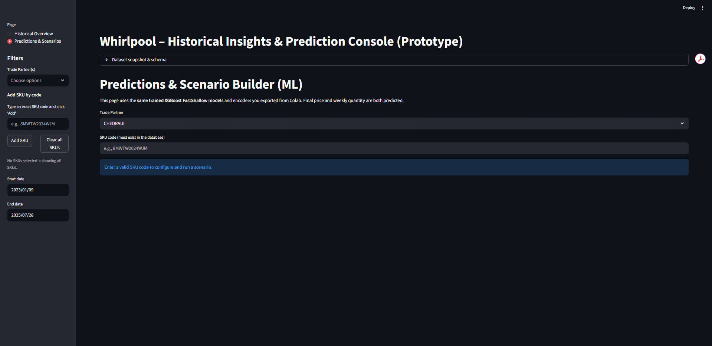
- Historical lagged behaviors (stored in base row)

Input Controls (Page 2)
Trade Partner Selector
- Dropdown with all TP codes.

SKU Manual Input
- User inputs a SKU code.
- Must exist in database and have records with the selected TP.
- Model loads historical patterns for this SKU and TP.

Discount Slider
- 0% to 80%

Week of Year Slider
1 to 52
- Represents the scenario week in 2026
- Model predicts for that hypothetical future week
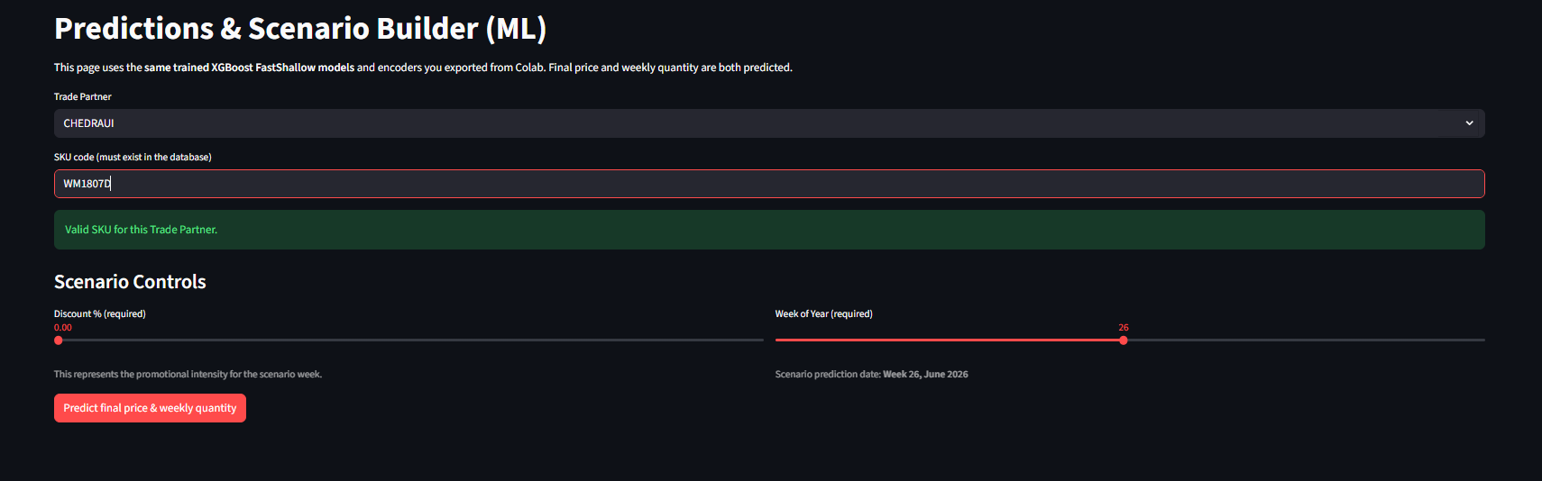
- Dashboard calculates what month that week corresponds to

Prediction Results and Historical vs Scenario Charts (Page 2)
Final Price Prediction
Displayed in MXN (after inverse log transform)

Quantity Prediction
Weekly quantity estimate (inverse log transform)

Interpretation
Predictions reflect:
- Seasonality
- SKU x TP historical behavior
- Discount impact

These two charts compare:
- Last 1.5 years of historical performance for the SKU x TP
- The future predicted point in 2026

What users see
- A line showing real historical values
- A gap (where 2025 data ends)
- A predictive point in 2026 (orange dot)

Purpose
- Highlight how price/quantity evolved historically
- Show where the prediction sits relative to past behavior
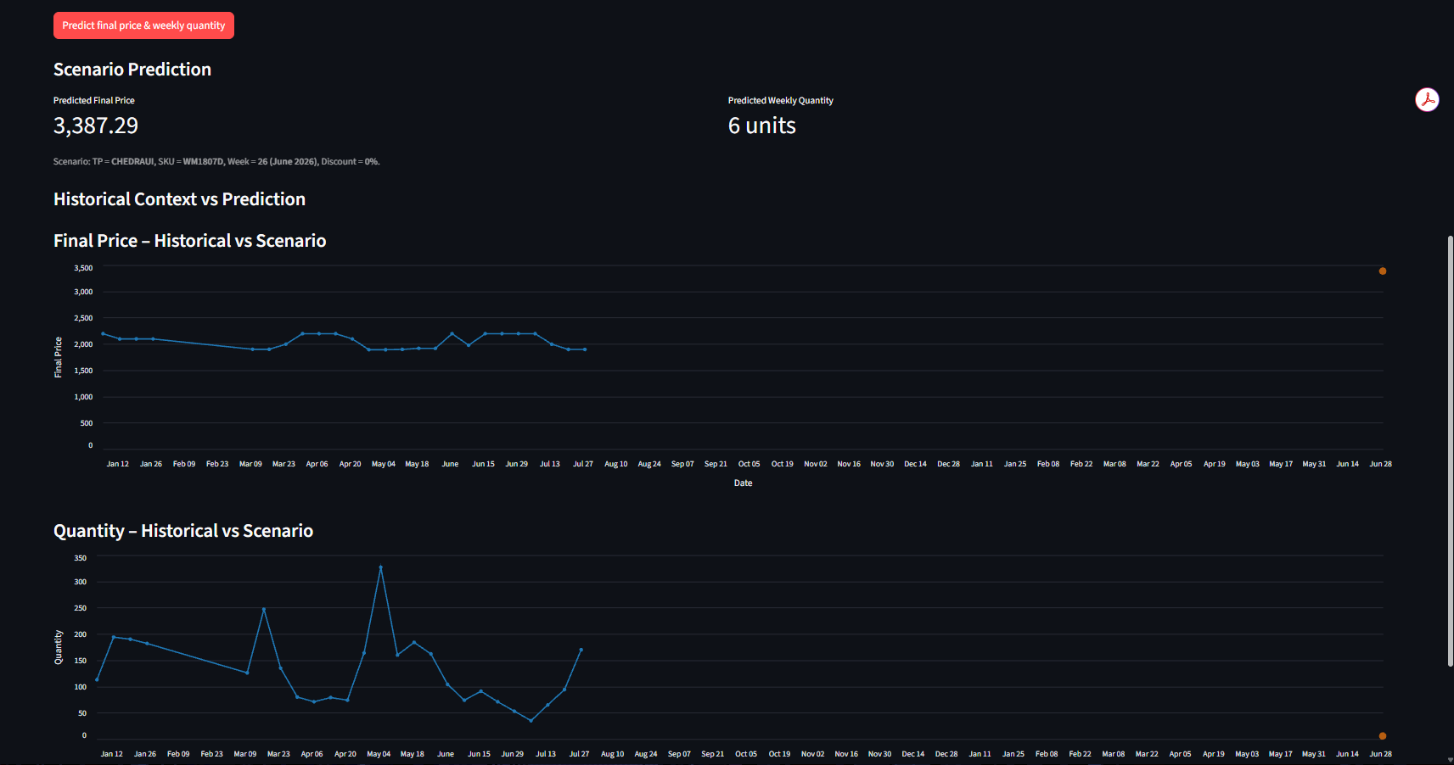
- Allow an intuitive comparison between “what normally happens” and the scenario

